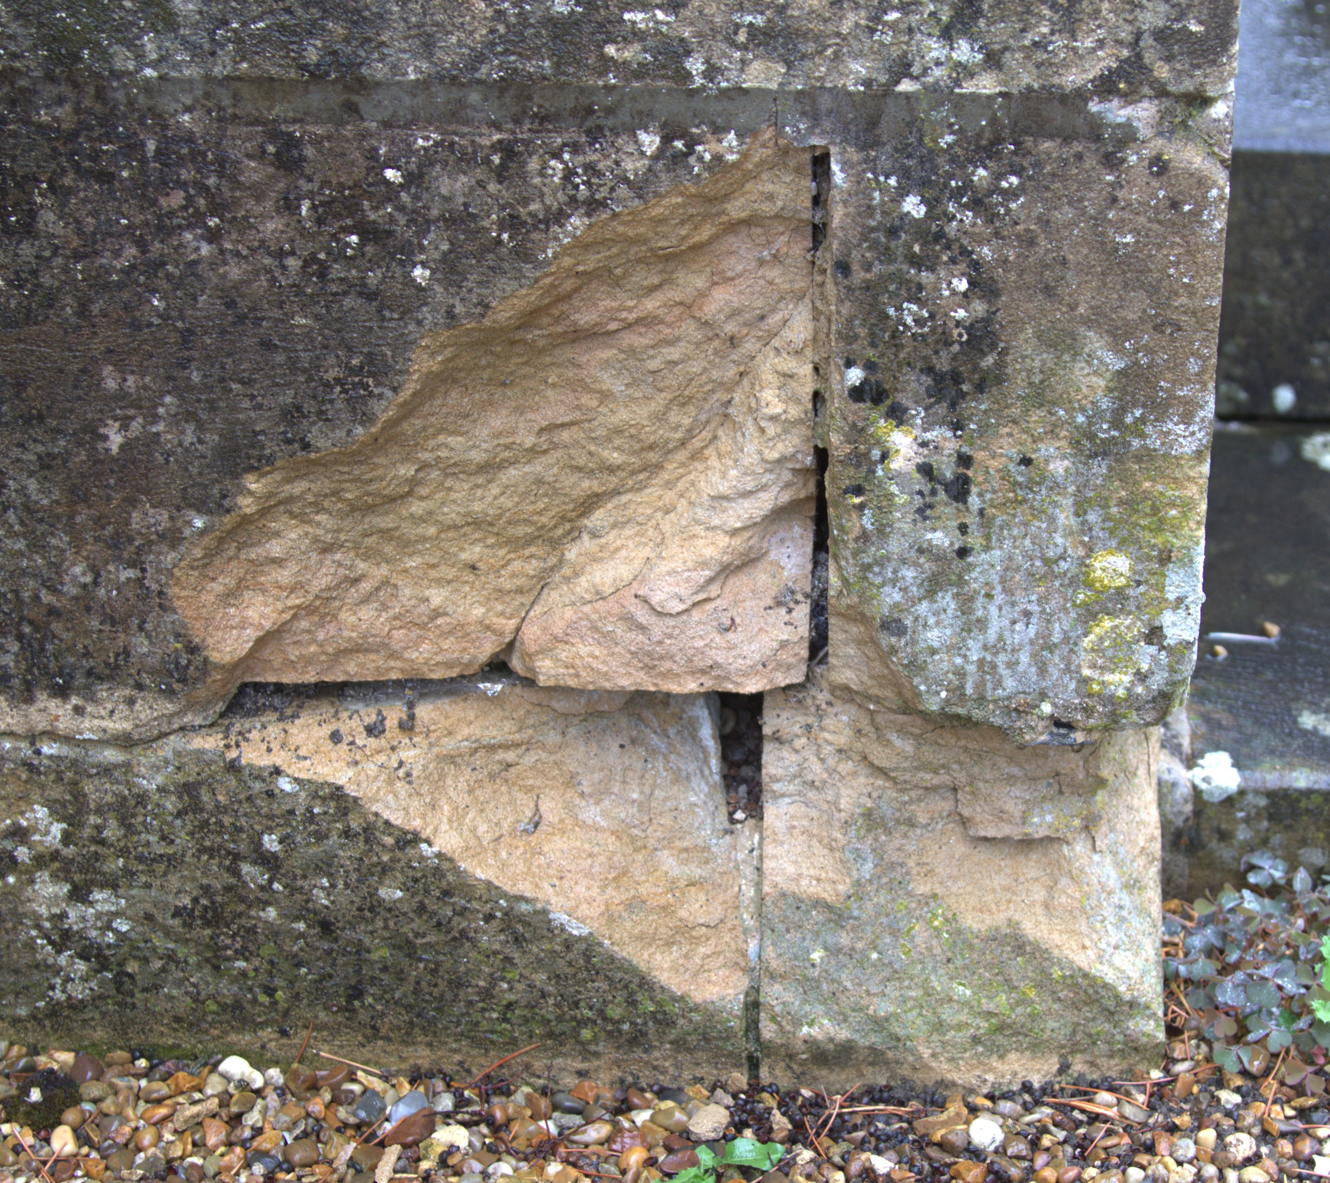
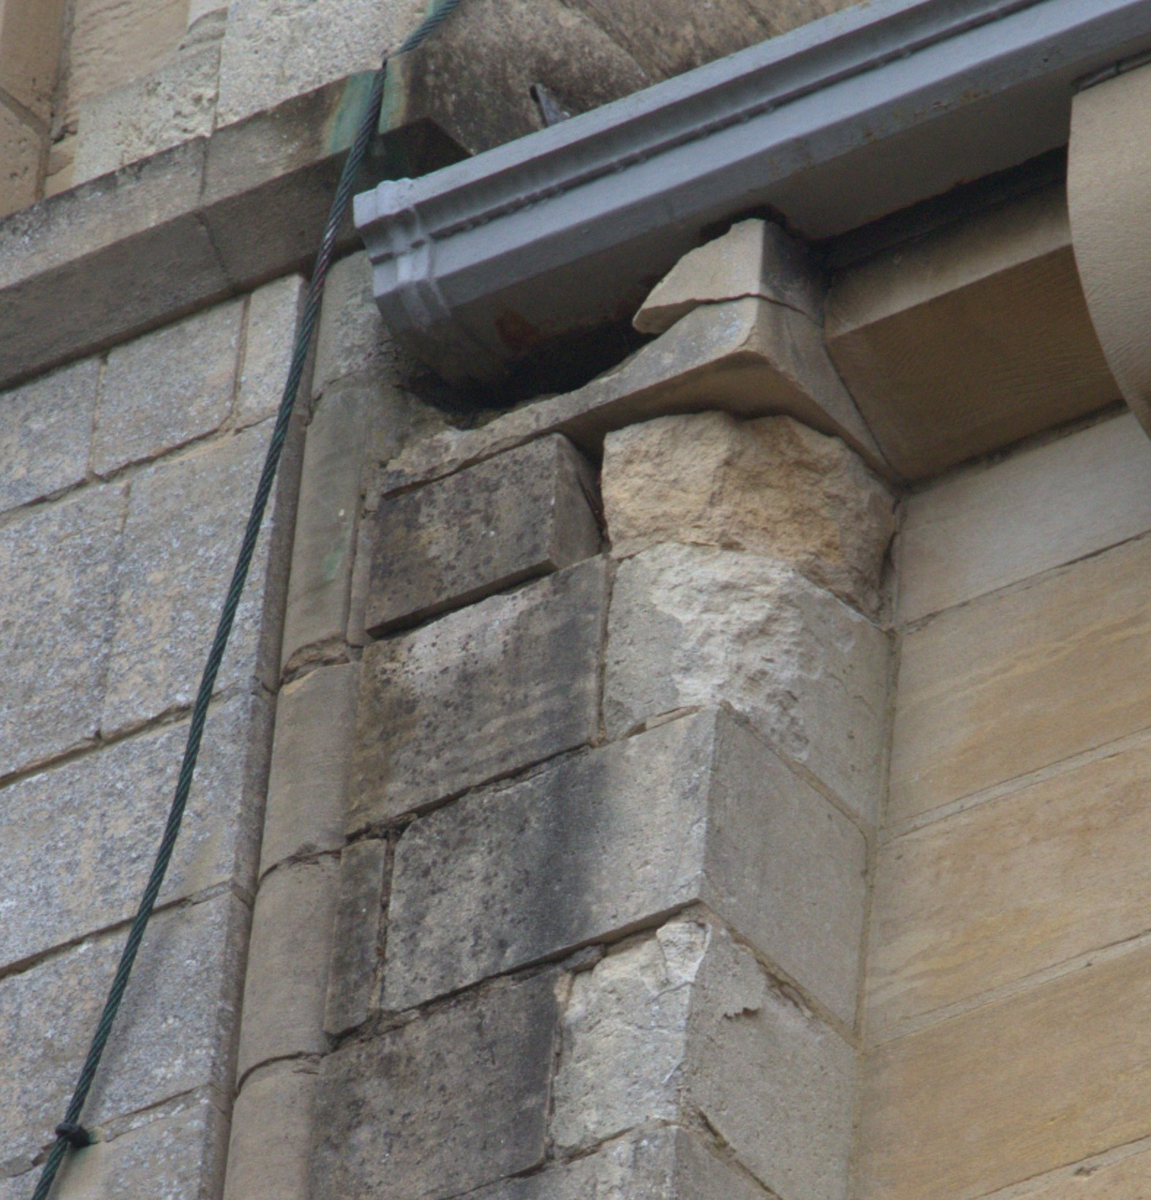
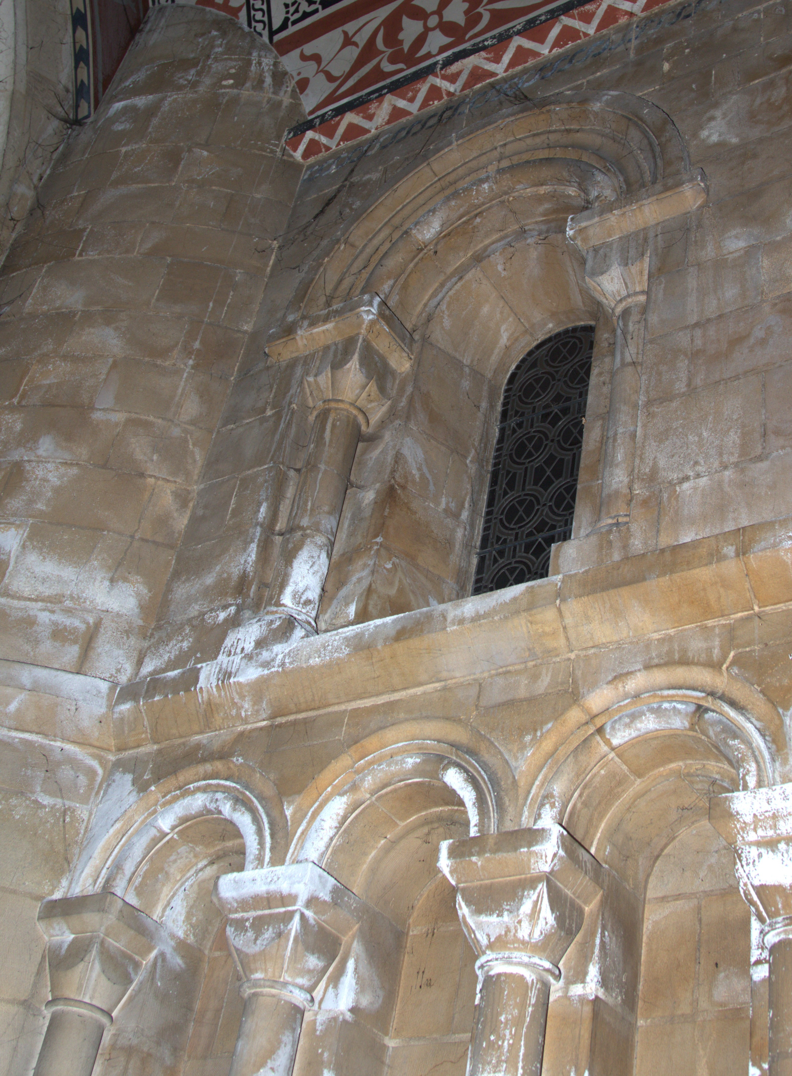
St Benet’s Fundraising
Issue 3 November 2025
UP-DATE

Yes, St Benet's Minster is on the Heritage at Risk Register. But what does that mean?
It means there are some areas within the building that need attention sooner than later. It also opens the door to larger grants. Some of those grants are straight funding of the work; others have to be percentage matched. But whether matched or not we have to show we care for our church and are willing to raise funds.

The Heritage at Risk Priority System
Historic England uses priority categories (A–F) to indicate the urgency and type of action needed to save or repair a heritage asset. Below is a simplified breakdown:
Priority | Meaning
A | Immediate risk of further rapid deterioration or loss of fabric; no solution agreed.
B | Immediate risk of further rapid deterioration or loss of fabric; solution agreed but not yet implemented.
C | Slow decay: no solution agreed. St Benet's is classified as a C
D | Slow decay: solution agreed but not yet implemented.
E | Under repair or in progress of being restored.
F | Repair scheme completed and the asset’s future secured (but may remain on register for monitoring).

“Priority C” specifically means: The heritage asset is in slow decay, not an emergency, but no repair or management solution has yet been agreed.
In other words, it’s not collapsing tomorrow, but it is deteriorating and still awaiting an agreed plan for conservation or restoration.

Why being on the Heritage at Risk Register helps
- Recognition of need
  - Inclusion on the register is an official acknowledgment that the site is at risk and in need of help.
  - This often strengthens applications for funding from Historic England, the National Lottery Heritage Fund, and other grant bodies, as it provides clear evidence of urgency and public value.
- Eligibility for grants
  - Being on the Heritage At Risk Register makes St Benet's a priority for all types of grant funding especially for:
    - Urgent repairs to listed buildings or scheduled monuments.
    - Condition surveys or conservation management plans.
    - Capacity-building (helping owners or trusts plan works).
- Leverage for match funding
  - Many funders ask for “match funding.” Being on the register can help convince local authorities, charities, or trusts to contribute, because it demonstrates official concern and oversight by a national heritage body.
- Access to technical support
  - Even when direct funding is not available, Historic England often provides specialist advice, feasibility studies, and advocacy to help owners move toward a sustainable solution.

In summary:
Being on the Heritage at Risk Register does not guarantee funding, but it significantly increases eligibility and priority for grants and expert help.
Mike Ellwood (Parish Lead) and Fr Simon
Are working with the diocesan architect and diocesan heritage buildings team, Grants adviser and Communication officers. Both Mike and Fr Simon have experience in these areas.

If you would like to make a donation to the Restoration Fund St B (one off or regular) leave a legacy in a Will, please speak to Fr Simon or Pamela St Mart (Pamela is keeping a record donation/fundraising).

Willing to help raise money to show we care about the restoration of St Benet's Minster. There is no committee, just people coming together in a single cause. The aim is to organise an event each month on a six-month rolling calendar bases, which will both raise money for the restoration and brings people together.

Can you run an event, i.e. a quiz, a supper evening or a stall? Would you be willing to help with an event?
Please come forward and bring your ideas. The more willing helpers, the easier it will be to spread the load.

There is a WhatsApp group. Join the group to share and keep up to date or offer your help. You may have a knowledge or skill to offer from organising to giving your time. Importantly, we need people to run events, support events, bringing with them friends and family.

If you would like to help, please just come and talk to:
Pamela St Mart 07909762758, Karen, Aloma or Linda 07468692180 linda.michael.last@icloud.com.

For the WhatsApp group, Aloma will need your name and mobile number.

There is a second front: The Parish day -to -ay running costs.
The Sunday collection does not to cover the cost of running the churches, lighting, heating, candles, priest’s living costs etc. Can you give just a little bit more in the collection plate?
- Have you thought about setting up a Direct Debit?
- If you do have a Direct Debit set-up: when was the last time you reviewed/ increased the amount?
- Are you a taxpayer? Have you completed a Gift Aid form?
  - Whether you put cash in the plate or use the card machine or pay by Direct Debit, the church can claim via gift aid.
  - The parish via the Diocese can claim 25% from HMRC on your donation.
    - Taken from HMRC website (10th Nov 2025):
    - If you donate £20 x 25% = £5 in gift aid. This is because the £20 you donated is treated as if you've already paid basic rate tax on it. Your £20 represents 80% of the pre-tax amount, with the remaining 20% being the tax a charity can reclaim. So, your donation is actually worth £25 before tax.
    - If you are higher rate taxpayer extra relief can be claimed via Self-Assessment.

We are aware these are difficult times and, unfortunately, more of us may find ourselves paying tax. By completing a Gift Aid form, you will be contributing a little bit more, without feeling it in your pocket. If you wish to set up a Gift Aid, please contact Paul Quinn, Gift Aid coordinator.

The first six months of fundraising events (**These events are in the planning stage)

7th December St Nicholas Stall in the hall after Mass selling cakes and home-made goods. We are looking for donated items to sell. Cakes: if you are making a Christmas cake, why not bake a small one in a baked bean tin; home-made cards; knitted items; good condition toys and books. Please give us your support by donating items and buying from our stall. Please bring items to the church and leave in the Sacristy from Sunday 30th November to the morning of 7th December. Gold Coins always welcome!

Annual Christmas Hamper Raffle 2025 Pamela St Mart & Karen
Raffle of a Christmas Hamper(s) to be drawn on 21st December after 11am Mass. Once again, we hope people will give a Christmassy food or drink item to make up one, or even two, hampers. Raffle tickets on sale from 7th December. Items for the hampers can be left in the Church Sacristy from 7th December.

3rd January 2026 Pamela St Mart & Karen
Soup and roll lunch plus a slice of cake. Catch up with friends and fellow parishioners over a bowl of soup.
Please put your name(s) on the list at the back of the church if you would like to attend by end of December.
£5.00 adults and £2.50 children (under 3yrs free).

February
**Quiz night.

March (date to be announced)
**Family Fun Beetle Drive.

April 11th Angela & Martyn
Concert in St Benet's Minster. Details of time and tickets price to follow.

May (Date to be confirmed) Linda, Pamela & Karen
Talk by Robert Tilney (Antiques Road Show expert, local gunsmith, St Benet's School old boy).

